COMP9331-21T2-Lab exercise 1

Haojin Guo

z5216214

**Exercise 1: nslookup**

Which is the IP address of the website www.koala.com.au? In your opinion, what is the reason of having several IP addresses as an output? 2. Find out the name of the IP address 127.0.0.1. What is special about this IP address?

Q1.

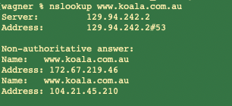

The IP address of the web [www.koala.com.au](http://www.koala.com.au) are “172.67.219.46” and “104.21.45.210”.

The website [www.koala.com.au](http://www.koala.com.au) has multiple IP addresses, first this operation allows each server running on a different end system, and each has a different IP address.

Also, this allows for Load balancing, and one of its important roles is to use multiple servers to provide a single service.

And, having multiple IP addresses can avoid single point failure.

Q2.

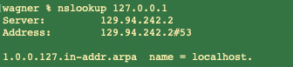

The name is “localhost”.

Specially, the IP address 127.0.0.1 here is Loop back Address, which is the data we send from host to the IP address starting with 127 will be received by host itself, and cannot be transmitted outside, and also the external device cannot access the machine through the Loopback Address.

And meanwhile, the name “localhost” is a domain name actually. Here, the localhost points to “127.0.0.1”

**Exercise2. Use ping to test host reachability**

1. Reachable webs are as follows:

[www.unsw.edu.au](http://www.unsw.edu.au)

[www.mit.edu](http://www.mit.edu) ,

[www.intel.com.au](http://www.intel.com.au) ,

[www.tpg.com.au](http://www.tpg.com.au/)

[www.amazon.com](http://www.amazon.com/)

[www.tsinghua.edu.cn](http://www.tsinghua.edu.cn/)

8.8.8.8

(ii)The non-existent webs are as follows:

[www.getfittest.com.au](http://www.getfittest.com.au)，

[www.hola.hp](http://www.hola.hp/)

(iii) Not reachable web:

[www.kremlin.ru](http://www.kremlin.ru/)

This web address unreachable by the ping command but is reachable from the web browser. The main possible reason is that this website are in a security factor to disable the ICMP protocol or enable ICMP packet filtering.

**Exercise3. Use traceroute to understand network topology**

1. Run traceroute on machine to [www.columbia.edu](http://www.columbia.edu/).

The output of traceroute is,

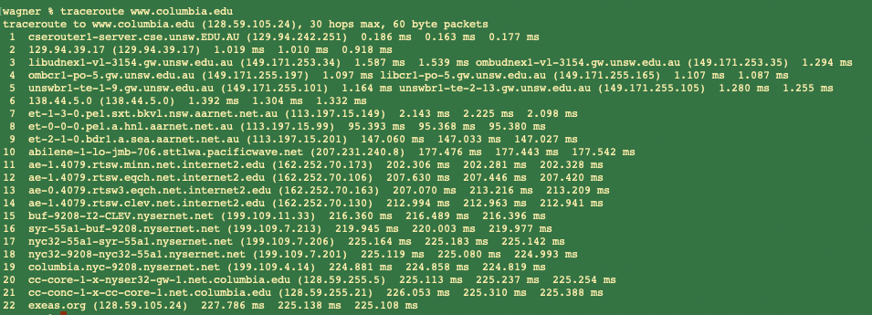

1. The output after tracreroute command shows there are 22 hops, and then there are

21 routers between my workstation and  [www.columbia.edu](http://www.columbia.edu/).

1. There are 5 routers are part of the UNSW networks based on their hostnames.

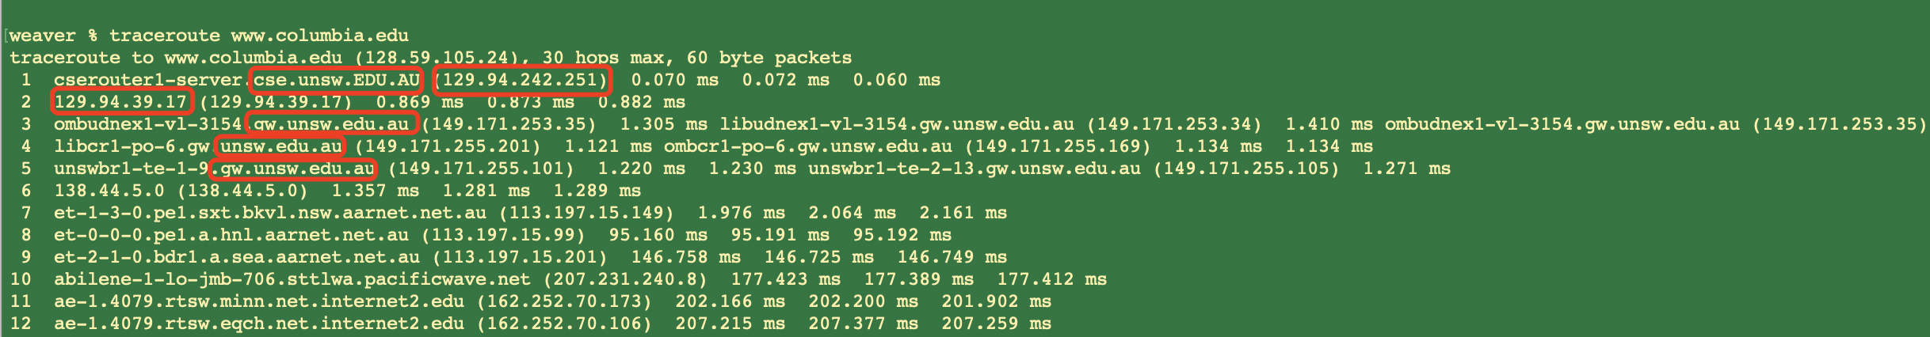

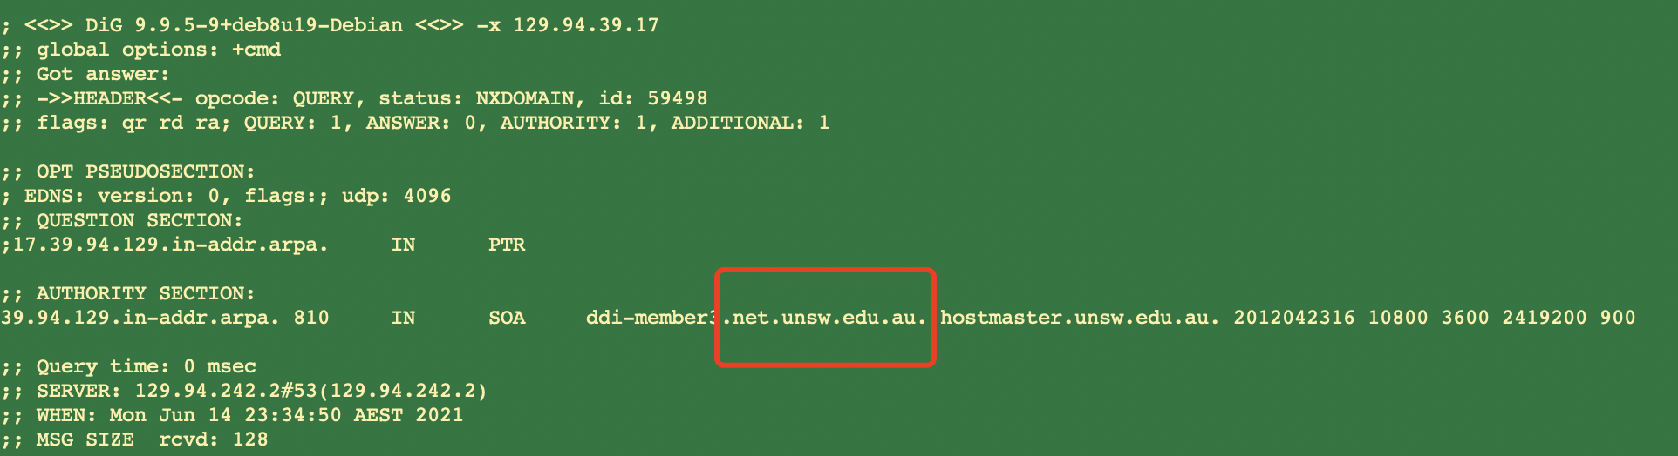

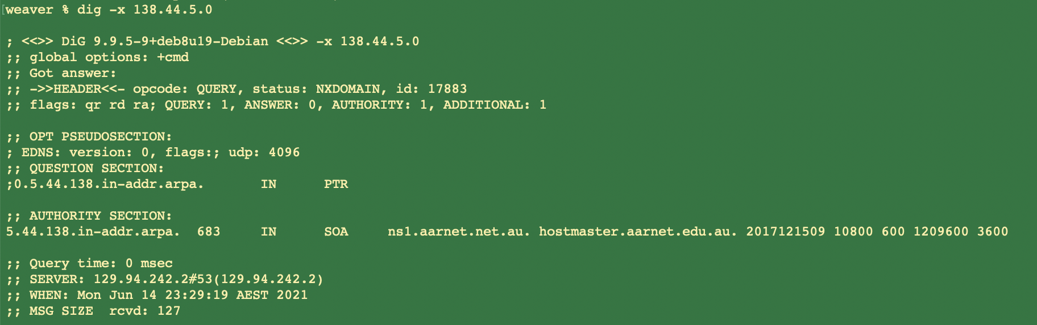

To be more specific, a reverse DNS query on 2th hop router indicates that this router is part of UNSW network. And also, a reverse DNS query on 6th hop router above shows that this router is part of the AARNET domain. Therefore, there are 5 routers are part of UNSW network.

From the specific information below:

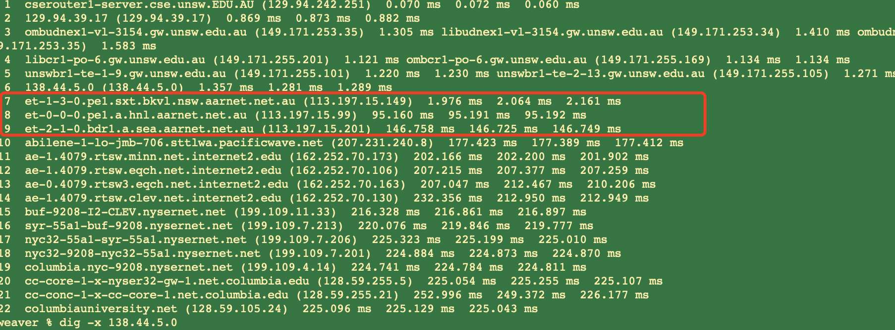

Hop 7-8 and 8-9 have a huge time jump. This suggests that this is where the path crosses the Pacific Ocean.

Also, from the information of 10th hop router, which is part of Pacificave network, it can roughly be known that the network before 7th hop and after 9th hop are located spans the Pacific Ocean.

1. Run traceroute from your machine to the following destinations:
2. Run traceroute on machine to [www.ucla.edu](http://www.ucla.edu )

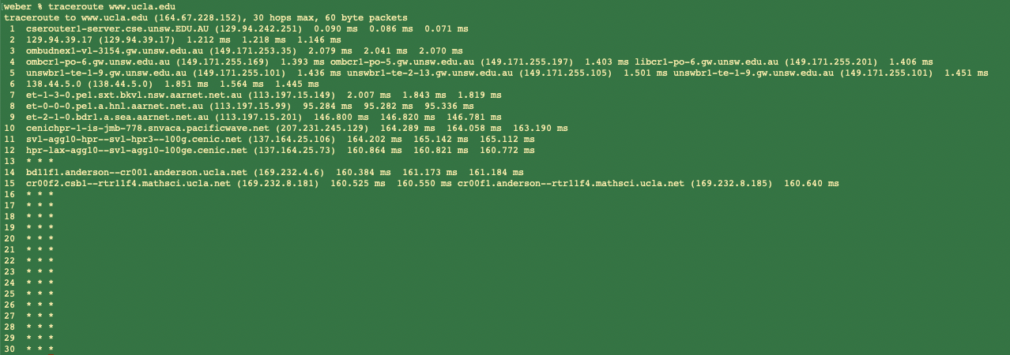

1. Run traceroute on machine to [www.u-tokyo.ac.jp](http://www.u-tokyo.ac.jp/)

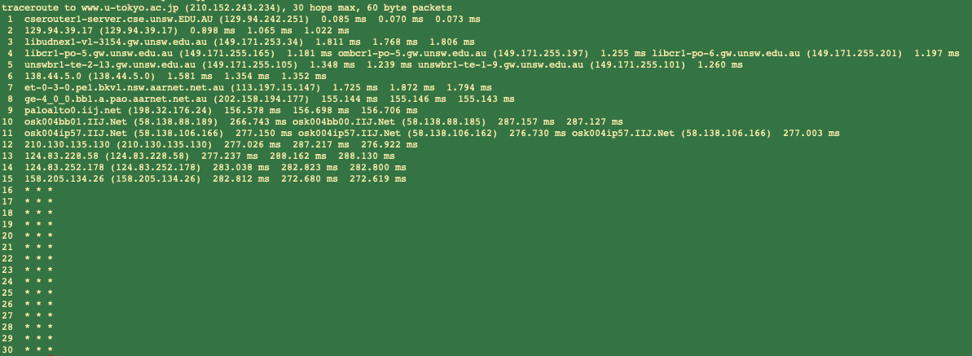

1. Run traceroute on machine to [www.lancaster.ac.uk](http://www.lancaster.ac.uk/)

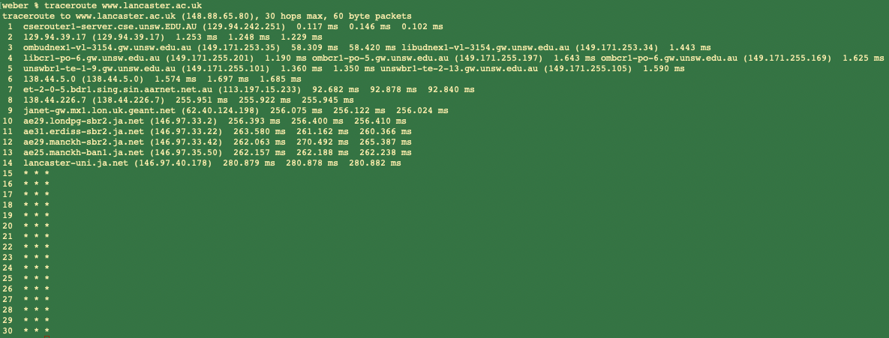

Specially, from the three outputs above, the first 6 hops are same, and then from 7th hop, the IP addresses are different. Therefore, the divergent router is 6th router, and the IP is 138.44.5.0.

The detail of this IP address 138.44.5.0. is as follows:

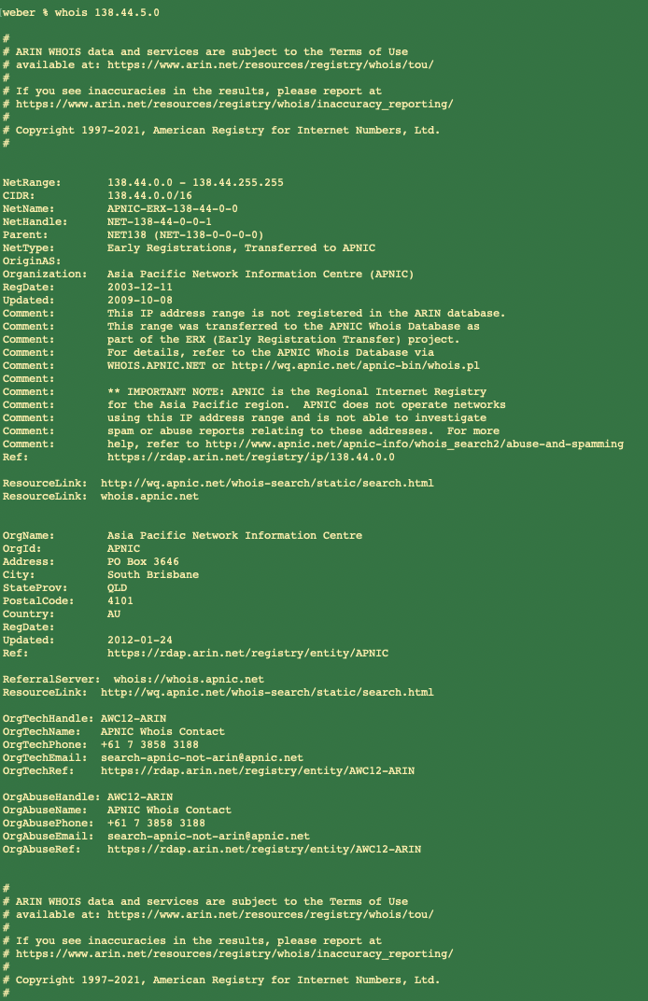

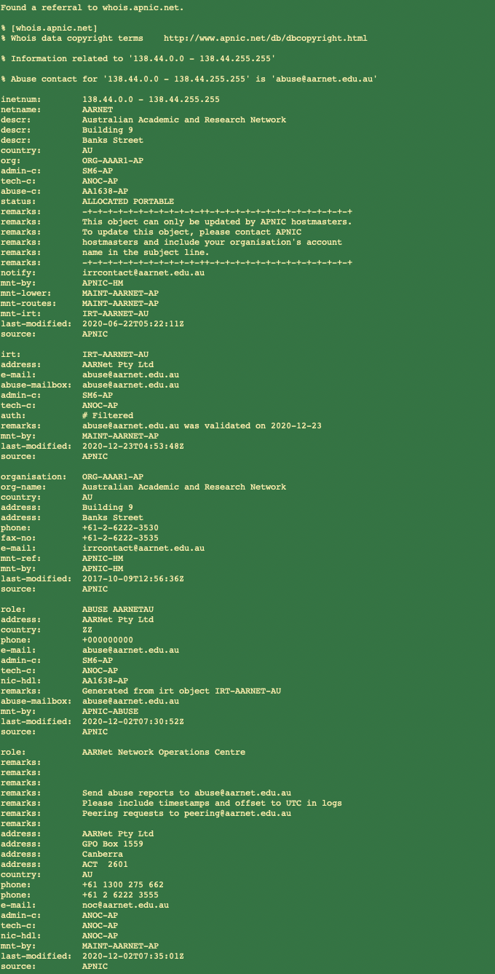

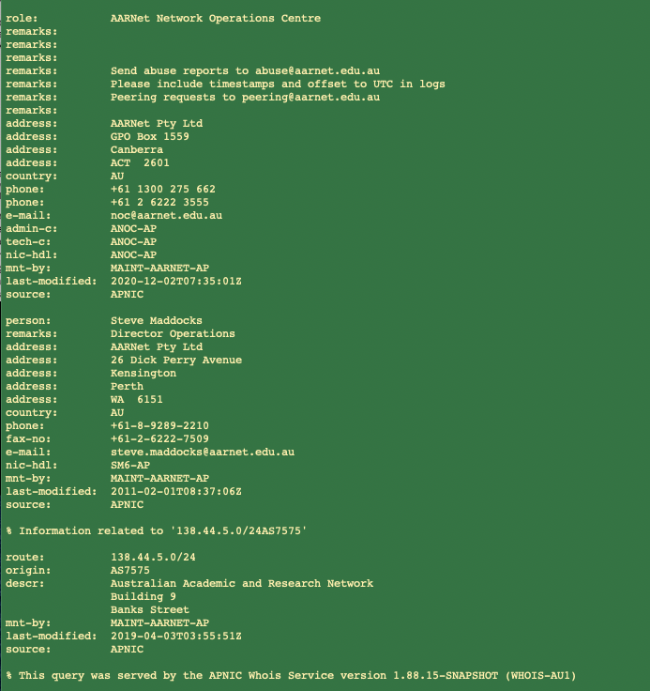

No, the number of hops on each path is not proportional the physical distance.

The specific reason is,

the physical distance from AU to UK (15196 km) is much greater than the distance from AU to JP (6848km),

however, access [www.u-tokyo.ac.jp](http://www.u-tokyo.ac.jp) experienced 15 hops, but access [www.lancaster.ac.uk](http://www.lancaster.ac.uk) experienced 14 hops.

1. Several servers distributed around the world: (i) <http://www.speedtest.com.sg/tr.php>and (ii) <https://www.telstra.net/cgi-bin/trace>.

Check my IP address first through the command /sbin/ifconfig is 129.94.242.55.

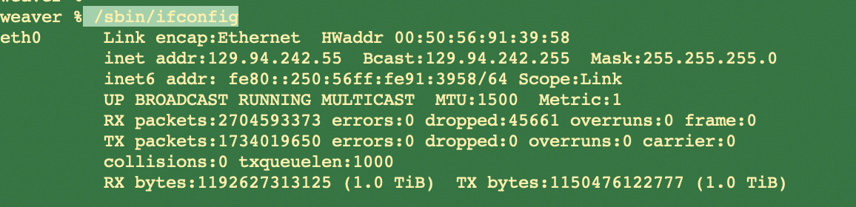

1)Run traceroute from servers towards local machine. (Reversed path)

[www.speedtest.com.sg](http://www.speedtest.com.sg/tr.php)

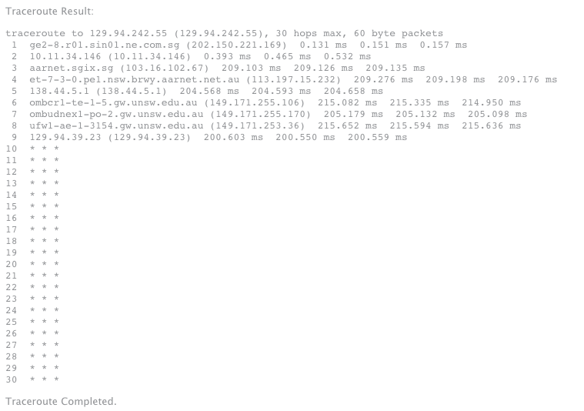

www.telstra.net

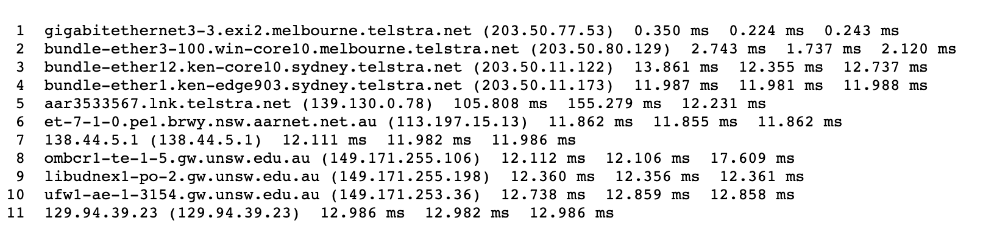

2)Run traceroute from my machine towards servers. (Forward path)

[www.speedtest.com.sg](http://www.speedtest.com.sg/tr.php) ( IP address is 202.150.221.170)

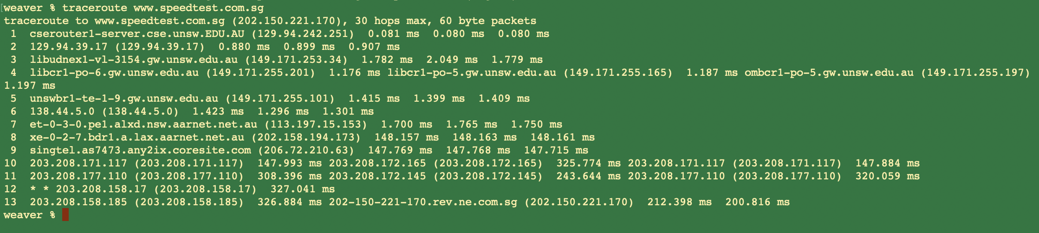

[www.telstra.net](http://www.telstra.net) ( IP address is 203.20.5.178)

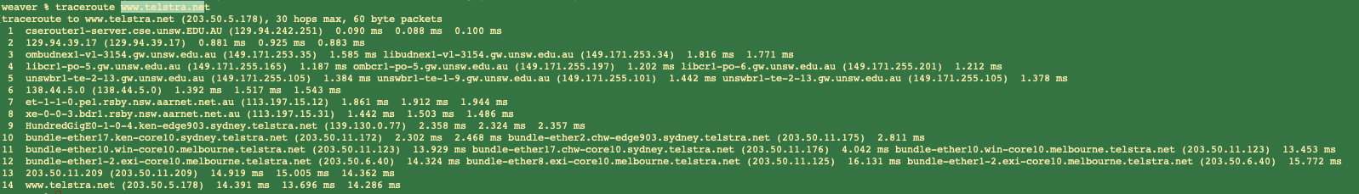

According to the results of forward path and reversed path, it can be found that they are not go through the same routers. Because in the process of router routing, the network topology is continuous changing (there may be router corruption, or router congestion, or other factors.). Hence, forward path and reverse path do not choose the same routers often. And meanwhile, because of the problem of load balancing, the same router will have mupltiple IP addresses.

#### Exercise 4. Use ping to gain insights into network performance

Q1.

The distance,

UNSW (Sydney) to Brisbane by air, 754km

UNSW (Sydney) to Serdang by air, 6243km

UNSW (Sydney) to Berlin by air, 16,093km

(Data from google)

Assuming the propagation speed is $3×{10}^{8} m/s$,

Then, the shortest (theoretically) possible time that a packet will take to reach the 3 locations from UNSW are:

$T_{Brisbane}= \frac{754km}{3×{10}^{8} m/s} ≈2.51ms$

$T_{Serdang}= \frac{6243km}{3×{10}^{8} m/s}=20.81ms$

$T_{Berlin}= \frac{16,093km}{3×{10}^{8} m/s} ≈53.64ms$

And from the corresponding *avg.txt flies, the minimum RTT (for 50 byte packets) to these 3 destinations are,

$$minRTT_{Bribane}=16.985ms$$

$$minRTT_{Serdang}=101.934ms$$

$$minRTT_{Berlin}=273.942ms$$

Therefore, the ratios are:

$R_{Brisbane}=\frac{16.985ms}{2.51ms}=6.767$

$R_{Serdang}=\frac{101.934ms}{20.81ms}$ = 4.898

$R_{Berlin}=\frac{273.942ms}{53.64ms}$ = 5.107

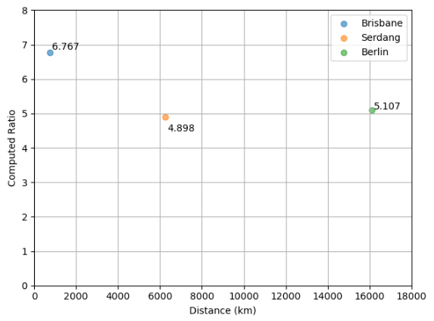

The values of y-axis are greater than 2.

The possible reasons are as follows,

a) The speed is lost in the pipeline network transmission process, which is lower than the theoretical speed ($3×{10}^{8} m/s$).

b) The distance in the transmission process is not a perfect straight-line distance, but the actual transmission distance is much higher than the two-point direct straight-line distance.

c) There is an unnegligible delay between each router.

Q2.

The delay to the destinations varies over time.

From the graphs of delay and scatter below, it is found that the horizontal coordinates of these graph are packet size (the number of packets). As time goes on, the number of packets (the amount of data) increases gradually. The overall graphs below shows that as the number of packet increases, the delay time increases (changes). Therefore, the delay to the destination varies over time.

(i)

Each of the following plots (destination_delay.pdf) indicates the delay of consecutive packets of same size, for different packet sizes:

1. www.uq.edu.au

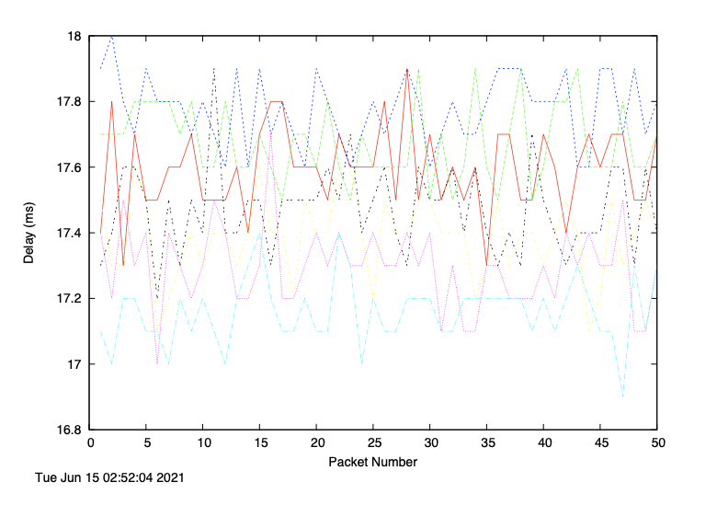

1. [www.upm.edu.my](http://www.upm.edu.my)

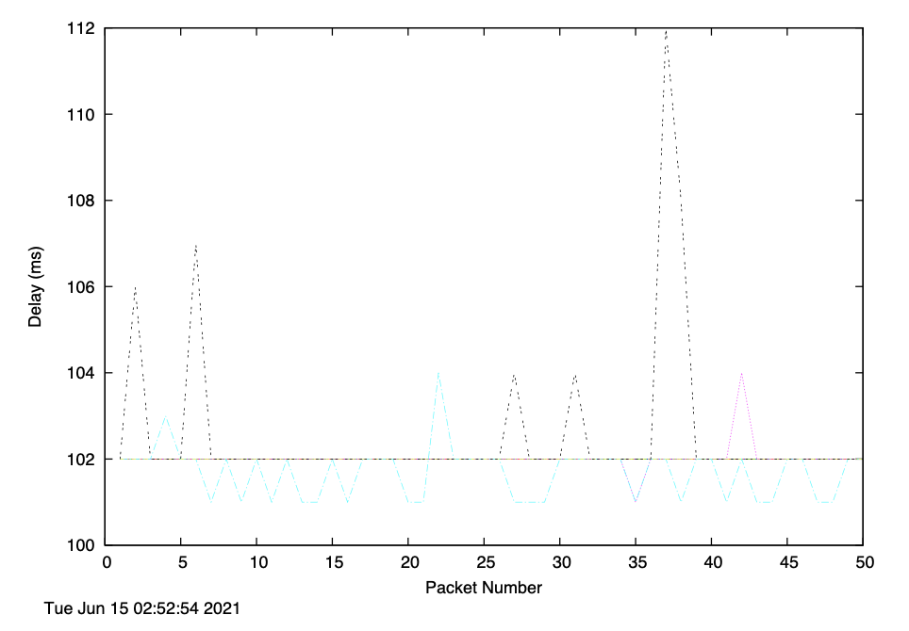

1. [www.tu-berlin.de](http://www.tu-berlin.de)

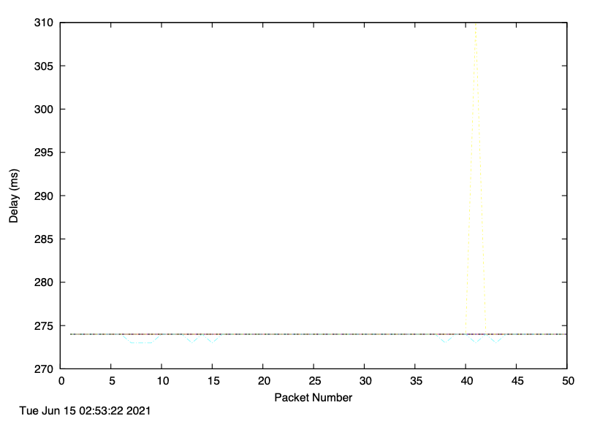

(ii)

The following plots (destination_scatter.pdf) depict the various measurements of delay as a scatter plot for different packet sizes.

1. [www.uq.edu.au](http://www.uq.edu.au)

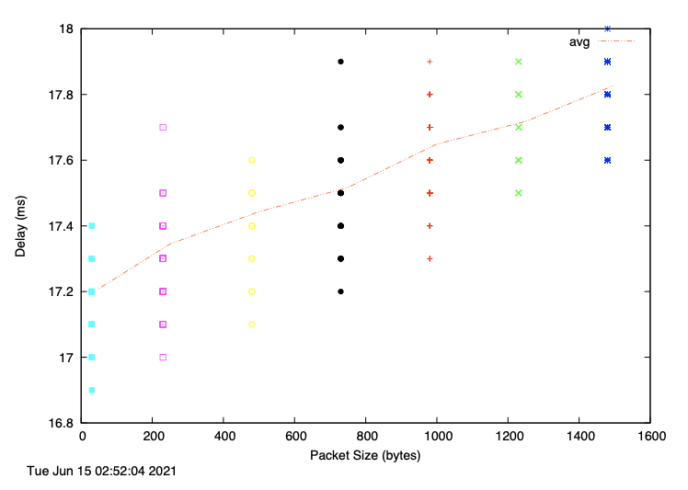

1. [www.upm.edu.my](http://www.upm.edu.my)

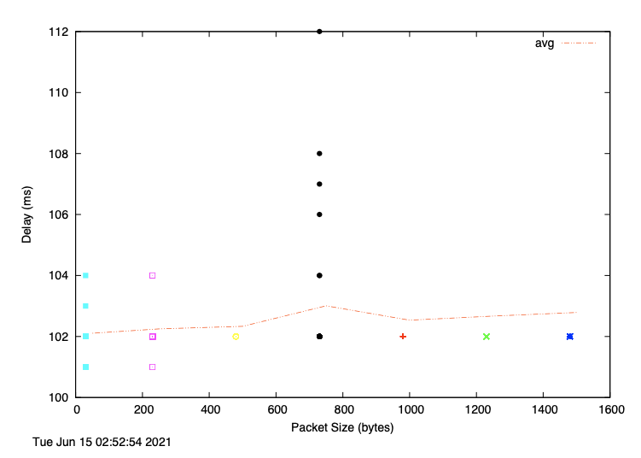

1. [www.tu-berlin.de](http://www.tu-berlin.de)

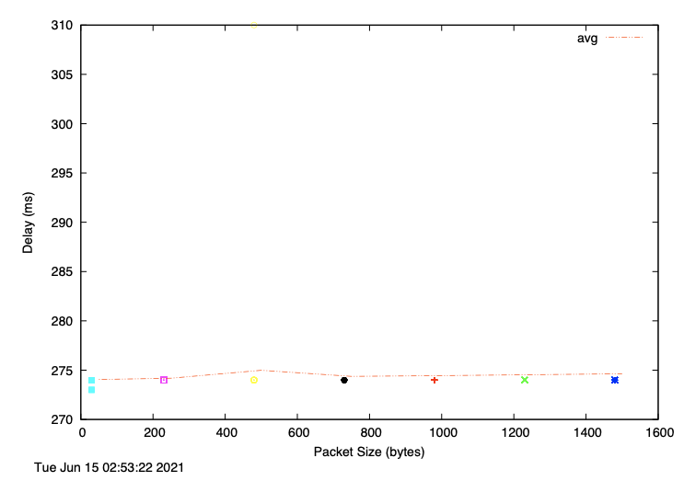

Q3.

The website [www.epfl.ch](http://www.epfl.ch) is not hosted in Switzerland.

By the nslookup command, the real(canonical) name of this web is www.epfl.ch.cdn.cloudflare.net.

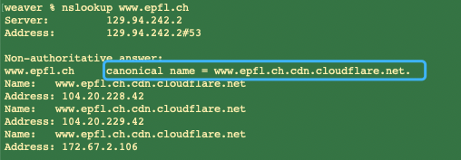

Then, by the whois command, we can find that this web hosted in the US.

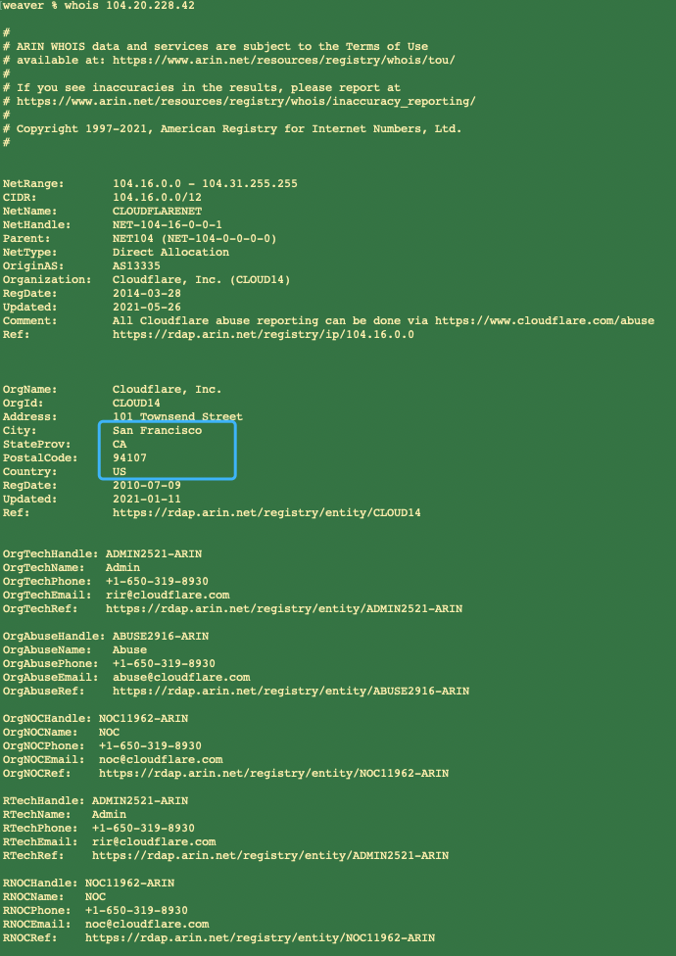

Q4.

1. Propagation delay depends on the distance of channel and the speed. It has nothing to do with packet size.
2. Transmission delay depends on packet size because $d_{trans}=\frac{L}{R} (where,L=\frac{packet size}{n} ， R=link bandwidth )$.
3. Node processing delay, it need to process packets, hence it depend on packet size.
4. Queuing delay, it is related to data inflow speed, outflow speed and buffer size, and so it does depend on the packet size.

Therefore, transmission delay, processing delay and queuing delay are depend on packet size.